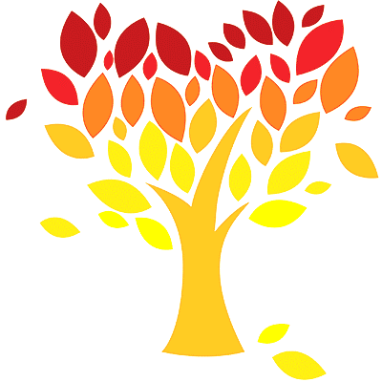
News from the Ark
a newsletter for our class and their families
11-9-2017

Food, Voting, and Being Thankful
We have been sharing some of our favorite foods this month during calendar and when we clap the beats in words. Tuesday, we used paper to make our favorite foods during art with
Mrs. Merkling. What kind of food did you make? How did you make it?

During circle time, we made a list of some of our favorite fruits. We voted to choose the three kinds of fruit that we will have at our Thanksgiving feast. We raised our hands to vote (to show which fruits we wanted), Mrs. Driscoll counted the votes, and we all helped figure out which fruits had the most votes. Do you remember the three fruits that were chosen? Applesauce, watermelon, and strawberries!

When we were voting, everyone was able to share their ideas and to help choose what we were going to get for our feast. We could see what everyone was voting for, but we did our best to vote for the things we wanted.
On Election Day, grown-ups get to vote to help choose the people who will decide how to take care of our towns, state, and country. They also get to make some decisions themselves. We stopped by the gym on our way to church. The gym in our building is one of the places grown-ups can go to vote. The people who are in charge of voting showed us how the grown-ups vote :

they sign in when they come to vote, they mark their votes on special papers (the grown-ups’ votes are secret), and they put the papers in a machine that counts the votes. Besides showing us how grown-ups vote, the nice people who were in charge of the voting gave us stickers that said we voted. What did we vote on? (The fruit for our feast!)

On our way from the gym to church, we passed by a table with baskets on it. The food pantry in our building helps people who don’t have enough money to buy food for their families. People from the church give food or money for food to the pantry so they can share what God has given them with people who need help. The baskets on the table have pieces of paper with different kinds of food written on them. People from our church can take the papers and bring back the food on them for special Thanksgiving food baskets that are given to the people who use the pantry. We’ll be talking more about the pantry and visiting it next week. What can you do at home to earn some food to give to the food pantry?

In church, we said a prayer thanking God for our favorite foods. What did you thank God for?

Happy birthday
to Zachary F.!
Picture Day
Tuesday was picture day at school. We had pictures taken together and by ourselves. Why do people take pictures? Sometimes they take pictures to help them remember special times and people. Do you have any special photographs of your family? There are a lot of pictures of our class on the preschool website. Do any of them remind you something you really liked doing in our class this year?

Thank you to
the families who visited with
Mrs. Driscoll this week
(and the ones who are visiting next week)!

Telling Stories
We started learning some yoga poses that match the people and animals in The Napping House Monday. Today, we read the book and then acted it out with our poses. Can you show someone 2 poses we learned?

There are a lot of different animals and things on the bed in the story. We can use our eyes to see different things but we can also use our hands to feel different things. We played a game with Mrs. Merkling using our hands. What did we do?

Yesterday, we all told the story of the Three Little Pigs together! Can you tell someone the story? The pigs in the story all build their homes from different things. Do you remember what they used? We wrote book pages about our favorite things to use when we build; what did you write about?

The Big Bad Wolf climbed on the Pig’s roof toward the end of the story. What do our roofs usually keep out? We built roofs with different things and then tested them with Mrs. Merkling to see if they would keep water out. What did you build your roof with? Did it leak?

How did the Big Bad Wolf knock down the first two Pigs’ houses? We used air to play games and to do experiments today. How did we play one of the games with air? We breathe air in and out; how did we measure the air we breathe out? Can air knock things down like it did in the story? (How did we move the air to knock things down?) How can air make a sound?

Notes and Reminders-
If you didn’t get a chance to replace your child’s extra clothing with something warmer this week, you can bring labeled clothing in and we will exchange the clothing for you.

We will be starting class in the conference room every day next week.

We are collecting our library books on Thursday and resuming library day after Thanksgiving break.

We will be visiting the food pantry in our building Friday. Please have your child EARN a non-perishable food item to donate. (This activity will mean much more to your child if he or she does something to earn the food item.)

